EXERCISE 13
- Which command displays the MySQL version?
SELECT VERSION() AS mysql_version;
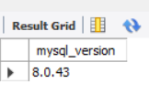
- Use the SELECT command to evaluate 4 X 4 X 4 and name the column Cube of 4.
SELECT (4 * 4 * 4) AS "Cube of 4";
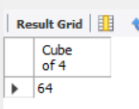
- Display your name with SELECT.
SELECT 'Your Name Here' AS Name;
